Chapter 1
1.1 Statistical Inference for a proportion
For the binomial distribution, the maximum likelihood estimator is $\hat{π}=\frac{y}{n}$ , which denotes the sample proportion.
1.2 Significance test about a binomial parameter
Consider the hypothesis $\left\{\begin{aligned}H_{0}:π=π_{0} \\ H_{1}:π≠π_{0}\end{aligned}\right.$, The test statistic is
$$z=\frac{ \hat{π}-π_{0}}{\sqrt{\frac{π_{0}(1-π_{0})}{n}}} .$$
1.3 Confidence Intervals for a binomial parameter
The $\left(1-α\right)\%$ Wald confidence interval for $π$ is
$$\hat{π}±z_{α/2}\sqrt{\frac{\hat{π}\left(1-\hat{π}\right)}{n}} .$$
The $\left(1-α\right)\%$ score confidence interval for $π$ is to solve the equation
$$\frac{| \hat{π}-π_{0}|}{\sqrt{\frac{π_{0}(1-π_{0})}{n}}}=± z_{α/2} .$$
1.4 Wald, Score, and Likelihood-Ratio Test

Chapter 2
2.1 Probability Structure for contingency tables
2.1.2 Sensitivity and Specificity
Let $X$ denote the true state of a person $(1=diseased, 2=not diseased)$, and let $Y=outcome of diagnostic test (1=positive, 2=negative)$. Then
$$Sensitivity=P\left(Y=1 | X=1\right), Specificity=P\left(Y=2 | X=2\right).$$
The higher the sensitivity and specificity, the better the diagnostic test.

2.2 Comparing proportions in $2×2$ contingency tables
2.2.1 Difference of proportions
Denote the probability of success by $π_{1}$ for subjects in row 1 and by $π_{2}$ for subjects in row 2. The difference $π_{1}-π_{2}$ compares the success probabilities for the two groups. Let ${\hat{π}}_{1}$ and ${\hat{π}}_{2}$ denote the sample proportions of successes. The sample difference of proportions ${\hat{π}}_{1}-{\hat{π}}_{2}$ estimates $π_{1}-π_{2}$.
For sample sizes $n_{1}$ and $n_{2}$ for the two groups, the estimated standard error of ${\hat{π}}_{1}-{\hat{π}}_{2}$ is
$$SE=\sqrt{\frac{{\hat{π}}_{1}(1-{\hat{π}}_{1})}{n_{1}}+\frac{{\hat{π}}_{2}(1-{\hat{π}}_{2})}{n_{2}}}.$$
A large sample $100\left(1-α\right)\%$ Wald confidence interval for $π_{1}-π_{2}$ is
$${\hat{π}}_{1}-{\hat{π}}_{2}±z_{α/2}SE.$$
For small samples, other confidence intervals perform better than Wald interval. They have actual coverage probability closer to the nominal confidence level, which is true when $π_{1}$ and $π_{2}$ are close to 0 or 1. It’s called score confidence interval.
Alternatively, simple fix of the Wald formula that improves its performance substantially is to add 1.0 to every cell of the $2×2$ table before applying it.

2.2.2 Example: Aspirin and Incidence of Heart Attacks

Table 2.2 Cross-classification of aspirin use and myocardial infarction (MI)
Group | Myocardial Infarction |  | Total
 | Yes | No
Placebo | 189 | 10,845 | 11,034
Aspirin | 104 | 10,933 | 11,037

We treat the two rows in Table 2.2 as independent binomial samples. For those taking placebo, the sample proportion is ${\hat{π}}_{1}=189/11,034=0.0171$, for those taking aspirin, the sample proportion is ${\hat{π}}_{2}=104/11,037=0.0094$.
The sample difference of proportions is ${\hat{π}}_{1}-{\hat{π}}_{2}=0.0171-0.0094=0.0077$, and the estimated standard error of ${\hat{π}}_{1}-{\hat{π}}_{2}$ is
$$SE=\sqrt{\frac{\left(0.0171\right)\left(0.9829\right)}{11,034}+\frac{\left(0.0094\right)\left(0.9906\right)}{11,037}}=0.0015.$$
A 95% confidence interval for $π_{1}-π_{2}$ is $0.0077±1.96\left(0.0015\right)=(0.0048, 0.0106)$. Since this interval contains only positive values, we conclude that $π_{1}>π_{2}$. Taking aspirin corresponds to a diminished risk of heart attack.

2.2.3 Ratio of proportions (Relative risk)
Consider a comparison of two pairs of proportions: $(0.001, 0.010)$ and $(0.401, 0.410)$. The difference between 0.010 and 0.001 is the same as the difference between 0.410 and 0.401, namely 0.009. However, the first difference is more striking, since 0.010 is ten times of 0.001. In such cases, the ratio of proportions is a more relevant descriptive measure. Using the difference of proportions alone to compare two groups can be misleading when the proportions are both close to zero.
For $2×2$ tables, the ratio of probabilities is called relative risk:
$$Relative risk=\frac{π_{1}}{π_{2}} .$$
For Table 2.2, the sample relative risk is ${\hat{π}}_{1}/{\hat{π}}_{2}=0.0171/0.0094=1.82$. The sample proportion of MI cased was 82% higher fir the group taking a placebo. The sample difference of proportions of 0.0077 makes it seem as if the two groups differ by a trivial amount.
For Table 2.2, R report a 95% confidence interval for the true relative risk of (1.43, 2.30). We infer that the probability of MI for taking placebo $(π_{1})$ is between 1.43 and 2.30 times the probability of MI for taking aspirin $(π_{2})$. Therefore, the risk of MI $(π_{1})$ is at least 43% higher for the placebo group.

2.3 Odds ratio
For a probability of success $π$, the odds of success are defined to be
$$odds=\frac{π}{1-π} .$$
For example, when $π=0.75$, the odds of success equal $0.75/0.25=3.0$. When $odds=3.0$, we expect to observe three successes for every one failure. When $odds=1/3$, a failure is three times as likely as a success, we then expect to observe one success for every three failures.
The success probability is the function of the odds,
$$π=odds/(odds+1).$$
For example, when $odds=4$, then $π=4/(4+1)=0.8$. The probability of success is 0.8, the probability of failure is 0.2, and the odds equal to $0.8/0.2=4$.
In $2×2$ tables, the ratio of the odds from the two rows,
$$θ=\frac{odds_{1}}{odds_{2}}=\frac{π_{1}/(1-π_{1})}{π_{2}/(1-π_{2})} ,$$
is called the odds ratio.
2.3.1 Properties of odds ratio
(1.1) When $X$ and $Y$ are independent, $π_{1}=π_{2}$, so $odds_{1}=odds_{2}$ and the odds ratio $θ=odds_{1}/odds_{2}=1$.
(1.2) When $θ>1$, the odds of success are higher in row 1 than in row 2. Thus, subjects in row 1 are more likely to have success than are subjects in row 2, that is, $π_{1}>π_{2}$. On the other hand, when $θ<1$, a success is less likely in row 1 than in row 2, that is, $π_{1}<π_{2}$.
For example, when $θ=4$, the odds of success in row 1 are four times the odds of success in row 2.
(2.1) When the order of the rows is reversed or the order of the columns is reversed, the new value of $θ$ is the reciprocal of the original value.
(2.2) When the rows become the columns and the columns become the rows, the odds ratio doesn’t change.
(3.1) The sample odds ratio can be calculated by
$$\hat{θ}=\frac{{\hat{π}}_{1}/(1-{\hat{π}}_{1})}{{\hat{π}}_{2}/(1-{\hat{π}}_{2})}=\frac{n_{11}/n_{12}}{n_{21}/n_{22}}=\frac{n_{11}n_{22}}{n_{12}n_{21}}.$$
2.3.2 Example: Odds ratio for aspirin use and heart attacks
In Table 2.2, for the placebo group, the estimated odds of MI equal $n_{11}/n_{12}=189/10,845=0.0174$, which means there were 1.74 “Yes” outcomes for every 100 “No” outcomes. For the aspirin group, the estimated odds of MI equal $104/10,933=0.0095$, which means there were 0.95 “Yes” outcomes per every 100 “No” outcomes.
The sample odds ratio equals $\hat{θ}=0.0174/0.0095=1.832$. The estimated odds of MI for those taking placebo equal 1.83 times the estimated odds for those taking aspirin. The estimated odds were 83% higher for the placebo group.

2.3.3 Inference for odds ratio and log odds ratios
Since the sampling distribution of the odds ratio is highly skewed, statistical inference uses its natural logarithm, $\log\left(θ\right)$. The sample log odds ratio $\log\left(\hat{θ}\right)$ has a less-skewed, bell-shaped sampling distribution. Its approximating normal distribution has a mean of $\log{(θ)}$ and a standard error of
$$SE=\sqrt{\frac{1}{n_{11}}+\frac{1}{n_{12}}+\frac{1}{n_{21}}+\frac{1}{n_{22}}}.$$
A large-sample Wald confidence interval for $\log\left(θ\right)$ is
$$\log\left(\hat{θ}\right)±z_{α/2}(SE).$$
For Table 2.2, $\log\left(\hat{θ}\right)=\log{(1.832)}=0.605$ and the $SE$ of $\log\left(\hat{θ}\right)$ is $SE=\sqrt{\frac{1}{189}+\frac{1}{10,933}+\frac{1}{104}+\frac{1}{10,845}}=0.123.$ A 95% confidence interval for $\log\left(θ\right)$ equals
$$0.605±1.96\left(0.123\right)=\left(0.365, 0.846\right).$$
The corresponding confidence interval for $θ$ is
$$\left(e^{0.365},e^{0.846}\right)=\left(1.44, 2.33\right).$$
Since the confidence interval $\left(1.44, 2.33\right)$ for $θ$ does not contain the “no effect” value of 1.0, the true odds of MI seem different for the two groups. We estimate that the odds of MI are at least 44% higher when taking placebo than when taking aspirin.
For small samples, using score CI (available in R) is better than Wald CI. The score confidence interval is available even when an $n_{ij}=0$.
2.3.4 Relationship between odds ratio and relative risk
From the formula of odds ratio and relative risk, we have
$$Odds ratio=\frac{{\hat{π}}_{1}/(1-{\hat{π}}_{1})}{{\hat{π}}_{2}/(1-{\hat{π}}_{2})}=Relative risk×\left(\frac{1-{\hat{π}}_{2}}{1-{\hat{π}}_{1}}\right).$$
When ${\hat{π}}_{1}$ and ${\hat{π}}_{2}$ are both close to zero, $\left(\frac{1-{\hat{π}}_{2}}{1-{\hat{π}}_{1}}\right)$ equals approximately 1.0. The odds ratio and relative risk then take similar values.
This relationship between the odds ratio and the relative risk is useful. For some data sets direct estimation of the relative risk is not possible, yet we can estimate the odds ratio and use it to approximate the relative risk when the proportions compared are small.
2.3.5 Example: the odds ratio applies in case-control studies

Table 2.3 Cross-classification of smoking by lung cancer.
Smoker | Lung Cancer
 | Cases | Controls
Yes | 688 | 650
No | 21 | 59
Total | 709 | 709

Table 2.3 is a case-control study which comes from one of the first studies of the association between lung cancer and smoking. For those in Table 2.3 with lung cancer, the proportion who were smokers was $688/709 = 0.970$, while it was $650/709 = 0.917$ for the controls.
We can compute the odds ratio:
$$\hat{θ}=\frac{688×59}{650×21}=3.0.$$
The estimated odds of lung cancer for smokers were 3.0 times the estimated odds for nonsmokers.
If the probability of lung cancer is small regardless of smoking behavior, the odds ratio estimate of 3.0 is also a rough estimate of the relative risk; that is, smokers had about 3.0 times the relative frequency of lung cancer as nonsmokers.

2.4 Chi-squared tests of independence
2.4.1 Pearson statistic and the Chi-Squared distribution
Pearson chi-squared statistic for testing $H_{0}$ is
$$X^{2}=\sum{\frac{{\left(n_{ij}-μ_{ij}\right)}^{2}}{μ_{ij}}},$$
for large sample sizes $X^{2}$ has approximately a chi-squared distribution. The chi-squared approximation improves as {$μ_{ij}$} increase and {$μ_{ij}$ ≥ 5} is usually sufficient for a decent approximation.
2.4.2 Likelihood-Ratio Statistic
The Pearson statistic $X^{2}$ is a score statistic. the likelihood-ratio chi-squared statistic is
$$G^{2}=2\sum{n_{ij}\log\left(\frac{n_{ij}}{μ_{ij}}\right)}.$$
For testing independence in $r×c$ contingency tables, the approximate chi-squared sampling distributions of $X^{2}$ and $G^{2}$ have $df=(r-1)(c-1)$.

2.4.4 Example: Gender gap in political party affiliation

Table 2.4 Political party identification by gender, with estimated expected frequencies for independence in parentheses.
Gender | Political party identification
 | Democrat | Republican | Independent | Total
Female | 495 (456.9) | 272 (297.4) | 590 (602.6) | 1357
Male | 330 (368.1) | 265 (239.6) | 498 (485.4) | 1093
Total | 825 | 537 | 1088 | 2450
The chi-squared test statistics are $X^{2}=12.57$ and $G^{2}=12.60$, with $df=\left(r-1\right)\left(c-1\right)=\left(2-1\right)\left(3-1\right)=2$. Each statistic has a p-value of 0.002, both test statistics suggest that political party ID and gender are associated.

2.4.5 Residuals for cells in a contingency table
For the test of independence, a more useful cell residual is
$$\frac{n_{ij}-{\hat{μ}}_{ij}}{\sqrt{{\hat{μ}}_{ij}\left(1-{\hat{π}}_{i+}\right)\left(1-{\hat{π}}_{+j}\right)}}=\frac{n\left({\hat{π}}_{ij}-{\hat{π}}_{i+}{\hat{π}}_{+j}\right) }{\sqrt{n{\hat{π}}_{i+}{\hat{π}}_{+j}\left(1-{\hat{π}}_{i+}\right)\left(1-{\hat{π}}_{+j}\right)}} .$$
The denominator is the estimated standard error of the numerator, under $H_{0}$. This measure is called a standardized residual.
When $H_{0}$ is true, each standardized residual has a large-sample standard normal distribution. A standardized residual having an absolute value that exceeds about 2 when there are few cells or about 3 when there are many cells indicates lack of fit of $H_{0}$ in that cell. (Under $H_{0}$, we expect about 5% of the standardized residuals to be farther from 0 than $±2$ by chance alone.)
2.4.6 Partitioning Chi-Squared Statistics
$G^{2}$ statistic for testing independence can partition into two components. For example in Table 2.4, $G^{2}=12.60$ equals the sum of a $G^{2}$ statistic that compares the first two columns, plus a $G^{2}$ statistic for the $2×2$ table that combines the first two columns and compares them to the third column. Each component $G^{2}$ statistic has $df=1$. The first two columns have $G^{2}=11.536$, the second $2×2$ table combines these columns and compares them to the independent column have $G^{2}=1.065$.
The sum of these $G^{2}$ components equal $G^{2}$ for the test of independence for the full $2×3$ table. The Pearson $X^{2}$ for the full table does not equal the sum of $X^{2}$ values for the separate tables.
2.4.7 Limitation of chi-squared tests
1. Require large samples. The sampling distributions of $X^{2}$ and $G^{2}$ get closer to chi squared as n increases.
2. The chi-squared approximation is often poor for $G^{2}$ when some expected frequencies are less than about 5. Instead, use a small-sample test whenever at least one expected frequency is less than 5.
3. Chi-squared tests treat variables as nominal scale.

2.5 Testing independence for ordinal variables
2.5.1 Linear trend alternative to independence
When the variables are ordinal, a trend association is common. As the level of $X$ increases, responses on $Y$ tend to increase/decrease toward higher levels.
To detect a trend association, a simple analysis assigns ordered scores to categories and measures the degree of linear trend. The test statistic, which is sensitive to positive or negative linear trends, utilizes correlation information in the data.
Let $\overline{u}=\sum_{i}{u_{i} {\hat{π}}_{i+}}$ denote the sample mean of the row scores and let $\overline{v}=\sum_{j}{u_{v} {\hat{π}}_{+j}}$ denote the sample mean of the column scores. The sample correlation $R$ between $X$ and $Y$ is
$$R=\frac{\sum_{i,j}{\left(u_{i}-\overline{u}\right)\left(v_{j}-\overline{v}\right) {\hat{π}}_{ij} }}{\sqrt{\left[\sum_{i}{{\left(u_{i}-\overline{u}\right)}^{2} {\hat{π}}_{i+}}\right]\left[\sum_{j}{{\left(u_{j}-\overline{u}\right)}^{2} {\hat{π}}_{+j}}\right]}} .$$
For testing $H_{0}$: independence vs. $H_{a}:ρ≠0$, the test statistic
$$M^{2}=\left(n-1\right)R^{2}$$
has approximately a chi-squared distribution with $df=1$.

2.5.2 Example: Alcohol use and infant malformation
Table 2.6 Infant malformation and mother’s alcohol consumption.
Alcohol Consumption | Malformation
 | Absent | Present |  | Total |  | Percentage Present |  | Standardized Residual
0 | 17066 | 48 |  | 17114 |  | 0.28 |  | $$-0.18$$
$$<1$$ | 14464 | 38 |  | 14502 |  | 0.26 |  | $$-0.71$$
1-2 | 788 | 5 |  | 793 |  | 0.63 |  | 1.84
3-5 | 126 | 1 |  | 127 |  | 0.79 |  | 1.06
$$≥6$$ | 37 | 1 |  | 38 |  | 2.63 |  | 2.71

Table 2.6 has a mixture of very small, moderate, and extremely large counts. Even though the sample size is large $(n=32,574)$, in such cases the actual sampling distributions of $X^{2}$ or $G^{2}$ may not be close to chi squared. For these data, having $df=4$, $G^{2}=6.2 (p-value=0.19)$ and $X^{2}=12.1 (p-value=0.02)$ provide mixed signals.
To use the ordinal test statistic $M^{2}$, we assign scores to alcohol consumption that are midpoints of the categories: $v_{1}=0, v_{2}=0.5, v_{3}=1.5, v_{4}=4.0, v_{5}=7.0$, the last score being somewhat arbitrary. The sample correlation between alcohol consumption and malformation is $R=0.0142$. The test statistic $M^{2}=\left(n-1\right)R^{2}=\left(32573\right){\left(0.0142\right)}^{2}=6.57, p-value=0.010$, which suggests strong evidence of a nonzero correlation. The standard normal statistic $M=2.56$ has $p-value=0.005$ for $H_{a}:ρ>0$.
2.6 Exact frequentist and Bayesian inference
2.6.2 Fisher’s exact test for $2×2$ tables

Table 2.7 Potential result for Fisher’s tea tasting experiment.
 | Guess Poured First
Poured First | Milk | Tea | Total
Milk | 3 | 1 | 4
Tea | 1 | 3 | 4
Total | 4 | 4 | 8
Table 2.7 shows a potential result of the experiment. Consider $H_{0}:θ=1$ vs. $H_{a}:θ>1$.
The null distribution of $n_{11}$ is the hypergeometric distribution.
$$P\left(3\right)=\frac{\left({4 \atop 3}\right)\left({4 \atop 1}\right)}{\left({8 \atop 4}\right)}=\frac{16}{70}=0.229.$$
For $H_{a}:θ>1$, the only table that is more extreme in the direction of $H_{a}$ consists of four correct guesses. It has a probability of
$$P\left(4\right)=\frac{\left({4 \atop 4}\right)\left({4 \atop 0}\right)}{\left({8 \atop 4}\right)}=\frac{1}{70}=0.014.$$
The p-value for $H_{a}:θ>1$ equals the right-tail hypergeometric probability that $n_{11}$ is at least as large as observed. With $n_{11}=3$, the p-value is $P\left(3\right)+P\left(4\right)=0.243$.
For the two-sided $H_{a}:θ≠1$, its exact P-value is the two-tailed sum of the probabilities of tables no more likely than the observed table. For Table2.7, summing all probabilities that are no greater than the probability $P\left(3\right)=0.229$ gives p-value equal to $P\left(0\right)+P\left(1\right)+P\left(3\right)+P\left(4\right)=0.486$.

2.6.3 Conservatism for Actual P(Type I Error); Mid P-Values
Fisher’s exact test is conservative since the actual probability of a Type I error is smaller than a nominal value such as 0.05. To diminish the conservativeness, it’s recommended to use the mid P-value, which is half the probability of the observed result plus the probability of more extreme results.
For the tea-tasting data, with $n_{11}=3$, the one-sided mid P-value equals $P\left(3\right)/2 +P(4)=0.229/2 +0.014=0.129$.
As for confidence intervals for the odds ratio, it can also be based on exact distributions. This interval is shorter and has actual coverage probability that tends to be closer to the nominal level. For the tea-tasting data, the 95% CI of odds ratio based on the test using the mid-P value equals $\left(0.31, 306.6\right)$, obtained by R.

2.6.5 Bayesian Estimation for association measures
Bayesian methods assume that the number of successes $Y_{1}$ in row 1 has $Bin\left(n_{1},π_{1}\right)$ and the number of successes $Y_{2}$ in row 2 has $Bin\left(n_{2},π_{2}\right)$. With prior distributions $Beta\left(α_{1},β_{1}\right)$ for $π_{1}$ and $Beta\left(α_{2},β_{2}\right)$ for $π_{2}$, the posterior distribution is $Beta\left(y_{i}+α_{i} , n_{i}-y_{i}+β_{i}\right)$ for $π_{i} , i=1,2$.

2.6.6 Example: Bayesian Inference in a small clinical trial

Table 2.8 Clinical trial results
 | Guess Poured First
 | Success | Fail | Total
Treatment | 11 | 0 | 11
Control | 0 | 1 | 1
Total | 11 | 1 | 12
Table 2.8 Shows the result from a clinical trial. With $Beta(0.5,0.5)$ prior distribution for $π_{1}$ and $π_{2}$, the posterior distribution is $Beta\left(y_{1}+0.5, n_{1}-y_{1}+0.5\right)=Beta(11.5,0.5)$ for $π_{1}$ and $Beta\left(y_{2}+0.5, n_{2}-y_{2}+0.5\right)=Beta(0.5,1.5)$ for $π_{2}$. The 95% posterior interval for the odds ratio is (3.3, 1361274), but if we use uniform prior, the 95% posterior interval is (1.7, 4677).
However, the 95% confidence interval for the odds ratio is $(4.5,∞)$ using the large-sample score method and $\left(1.22, ∞\right)$ using the small-sample mid P-value method.

2.7 Association in three-way tables
2.7.1 Partial tables
For three-way contingency tables, two-way partial tables cross-classify $X$ and $Y$ at separate categories for $Z$.
The associations in partial tables are called conditional associations, because they refer to the effect of $X$ on $Y$ conditional on $Z$ being constant.
2.7.2 Example: Death penalty verdicts and race
Table 2.9 is a 2×2×2 contingency table that studied the effects of racial characteristics on whether subjects convicted of homicide receive the death penalty. The variables are $Y = death penalty verdict$, $X = race of defendant$, and $Z = race of victims$.
Table 2.9 Death penalty verdict by defendant’s race and victims’ race.
Victims’  Race | Defendant’s Race | Death Penalty |  | Percentage Yes
 |  | Yes | No
White | White | 53 | 414 | 11.3
 | Black | 11 | 37 | 22.9
Black | White | 0 | 16 | 0.0
 | Black | 4 | 139 | 2.8
Total | White | 53 | 430 | 11.0
 | Black | 15 | 176 | 7.9

When the victims were white, the death penalty was imposed $22.9\%-11.3\%=11.6\%$ more often for black defendants than for white defendants. When the victim was black, the death penalty was imposed $2.8\%-0.0\%=2.8\%$ more often for black defendants than for white defendants. Thus, controlling for victims’ race, the percentage of yes death penalty verdicts was higher for black defendants than for white defendants.
The bottom portion of Table 2.9 displays the marginal table for defendant’s race and the death penalty verdict. We obtain it by summing the cell counts in Table 2.9 over the two categories of victims’ race, thus combining the two partial tables. We see that, 11.0% of white defendants and 7.9% of black defendants received the death penalty. Ignoring victims’ race, the percentage of yes death penalty verdicts was lower for black defendants than for white defendants. The association reverses direction compared to the partial tables.

Chapter 3
3.1 Components of a GLM
3.1.1 Random Component
The random component of a GLM identifies the response variable $Y$ and assumes a probability distribution for it. Standard GLMs treat the $n$ observations on $Y$ as independent. We denote those observations by $(y_{1},…,y_{n})$.
If the observations are binary, then assume a binomial distribution for $Y$.
If each observation is a count, then assume a Poisson or negative binomial distribution for $Y$.
If each observation is continuous, then assume a normal distribution for $Y$.
3.1.2 Linear Predictor
The linear predictor of a GLM specifies the explanatory variables in the following form:
$$β_{0}+β_{1}x_{1}+…+β_{p}x_{p}$$
3.1.3 Link function
The expected value $μ=E[Y]$ of the probability distribution of $Y$ has a value that varies according to values of the explanatory variables. The third component of a GLM, the link function, specifies a function g that relates μ to the linear predictor as:
$$g\left(μ\right)=β_{0}+β_{1}x_{1}+…+β_{p}x_{p}$$
If $g\left(μ\right)=μ$, this is called the identity link function, and a GLM that uses identity link function is called ordinary linear model.
If $g\left(μ\right)=\log{(μ)}$, this is called the log link function, and a GLM that uses log link function is called a loglinear model.
If $g\left(μ\right)=\log\left(\frac{μ}{1-μ}\right)$, it models the log of an odds, this is called the logit link function, and a GLM that uses logit link function is called a logistic regression model.
3.2 GLM for binary data
3.2.2 Logistic regression model
The logistic regression model with multiple explanatory variables is:
$$logit[P\left(Y=1)\right]=\log\left[\frac{P\left(Y=1\right)}{1-P\left(Y=1\right)}\right]=β_{0}+β_{1}x_{1}+…+β_{p}x_{p}.$$
When $β>0$, $P(Y=1)$ increases as $x$ increases. When $β<0$, $P(Y=1)$ decreases as $x$ increases.
3.2.3 Example: Snoring and heart disease
Table 3.1 is a survey to investigate snoring as a possible risk factor for heart disease. We treat the rows of the table as four independent binomial samples. We use scores (0, 2, 4, 5) for $x=snoring level$.
Table 3.1 Relationship between snoring and heart disease
Snoring | Heart Disease |  | Proportion Yes | Linear  fit | Logistic  fit
 | Yes | No
Never | 24 | 1355 | 0.017 | 0.017 | 0.021
Occasional | 35 | 603 | 0.055 | 0.057 | 0.044
Never every night | 21 | 192 | 0.099 | 0.096 | 0.093
Every night | 30 | 224 | 0.118 | 0.116 | 0.132

The logistic regression model is fitted as follows (r code shows below):
$$logit\left[\hat{P}\left(Y=1\right)\right]=-3.866+0.397x.$$
Since $\hat{β}=0.397>0$, the estimated probability of heart disease increases as the snoring level increases.
```
data <- data.frame(y = c(24,35,21,30),n = c(1379,638,213,254),x = c(0,2,4,5))
fit <- glm(y/n ~ x, family=binomial(link=logit), weights=n, data = data)
summary(fit)
```
3.3 GLM for count data and rates
3.3.2 Poisson Loglinear model
The Poisson loglinear model has the form:
$$\log{(u)}=β_{0}+β_{1}x_{1}+…+β_{p}x_{p}.$$
And the mean satisfies the exponential relationship:
$$μ=e^{β_{0}+β_{1}x_{1}+…+β_{p}x_{p}}.$$
A one-unit increase in $x$ has a multiplicative impact of $e^{β}$ on $μ$. If $β=0$, then the mean of $Y$ doesn’t change as $x$ changes. If $β>0$, then $e^{β}>1$, and the mean of $Y$ increases as $x$ increases. If $β<0$, then $e^{β}<1$, and the mean of $Y$ decreases as $x$ increases.
3.3.3 Example: Female horseshoe crabs and their satellites
Table 3.2 Number of crab satellites by color, spine condition, shell width, and weight.
crab | sat | y | weight | width | color | spine
1 | 8 | 1 | 3.05 | 28.3 | 2 | 3
2 | 0 | 0 | 1.55 | 22.5 | 3 | 3
3 | 9 | 1 | 2.30 | 26.0 | 1 | 1
4 | 0 | 0 | 2.10 | 24.8 | 3 | 3

For the expected number of satellites $μ$ and shell width $x$ for a female crab, the Poisson loglinear model is fitted as follows:
$$\log{(\hat{μ})}=\hat{α}+\hat{β}x=-3.305+0.164x.$$
Since $\hat{β}>0$, width has a positive estimated effect on the number of satellites.
For the fitted value at the mean width of $x=26.3$ is
$$\hat{μ}=\exp\left(\hat{α}+\hat{β}x\right)=\exp\left[-3.305+0.164×26.3\right]=2.74.$$
For this model, $e^{\hat{β}}=e^{0.164}=1.178$ represents the multiplicative effect on the fitted value for each 1-cm increase in $x$. A 1-cm increase in the shell width has an 17.8% increase in the estimated mean number of satellites.
```
data <- read.table(“horseshoe crab.txt", header = T)
fit <- glm(sat ~ width, family = poisson(link=log), data = data)
summary(fit)
```

3.4 Statistical inference and model checking
3.4.1 Wald, Likelihood-Ratio, and Score Inference use the likelihood function
For a GLM with a single explanatory variable $x$, consider the hypothesis $H_{0}:β=0$ that $x$ has no effect on the response variable.
The Wald test statistic is $z=\hat{β}/SE$, where SE is the unrestricted standard error of $\hat{β}$.
For the likelihood-ratio approach, the likelihood-ratio test statistic equals
$$2\log{(l_{1}/l_{0})}=2\left[\log\left(l_{1}\right)-\log\left(l_{0}\right)\right]=2\left(L_{1}-L_{0}\right).$$
where $l_{0}$ and $l_{1}$ denote the maximized value of the likelihood function, $L_{0}$ and $L_{1}$ denote the maximized log-likelihood functions. Under $H_{0}:β=0$, this test statistic has an approximate $χ_{1}^{2}$.
The Wald 95% confidence interval for $β$ is
$$\hat{β}±z_{α/2}(SE)$$
The likelihood-ratio test-based confidence interval for $β$ is called a “profile likelihood confidence interval”.
3.4.2 Example: Political Ideology and Belief in Evolution
Let $y=option about evolutoin \left(1=true, 0=false\right)$ and $x=political ideology \left(1=extremely conservative, 2=conservative, 3=slightly conservative, 4=moderate, 5=slightly liberal, 6=liberal, 7=extremely liberal\right)$. The survey result shows in Table 3.3.

Table 3.3 Survey result of political ideology and belief in evolution
Ideology | True | False
1 | 11 | 37
2 | 46 | 104
3 | 70 | 72
4 | 241 | 214
5 | 78 | 36
6 | 89 | 24
7 | 36 | 6

The logistic regression model is fitted as $logit\left[\hat{P}\left(y=1\right)\right]=-1.757+0.494x$. The ideology effect $\hat{β}=0.494$ has $SE=0.051$.
For the hypothesis $H_{0}:β=0$, the Wald test statistic is
$$z=\frac{\hat{β}}{SE}=\frac{0.494}{0.051}=9.71$$
or $z^{2}=96.2$ as a chi-square with $df=1$. This provides extremely strong evidence that belief in evolution increases as political ideology is more liberal (p-value < 0.0001).
For the likelihood-ratio test, the chi-square statistic equals $2\left(L_{1}-L_{0}\right)=109.48$ with $df=1$ (p-value < 0.0001).
The Wald 95% CI for $β$ is $\hat{β}±1.96\left(SE\right)=0.494±1.96\left(0.051\right)=(0.394,0.594)$. From the R output, the profile likelihood 95% CI for $β$ is $(0.396,0.596)$.
```
data <- data.frame(ideology = c(1,2,3,4,5,6,7), True = c(11,46,70,241,78,89,36), False = c(37,104,72,214,36,24,6))
n <- c(48,150,142,455,114,113,42)
fit <- glm(True/n ~ ideology, family = binomial, weights = n, data = data)
summary(fit)
confint(fit) # profile likelihood CI
```

3.4.3 The deviance of a GLM
This model has a separate parameter for each observation, and it provides a perfect fit to the data. The model is said to be saturated.
The deviance of a GLM is defined to be
$$Deviance=2\left(L_{S}-L_{M}\right).$$
where $L_{M}$ denote the maximized log-likelihood value for a model $M$ of interest, and $L_{S}$ denote the maximized log-likelihood value for the most complex model, which provides a perfect fit to the data by having separate parameters for each observation. It is called saturated model.

The deviance is the likelihood-ratio statistic for comparing model M to the saturated model. It is a test statistic for the hypothesis that all parameters that are in the saturated model but not in model M equal zero. The deviance has approximately a chi-squared distribution. The residual $df$ equals the number of observations minus the number of model parameters. The p-value is the right-tail probability above the observed test statistic value, from the chi-squared distribution.
Given that the more complex model ($M_{1}$) holds, the likelihood-ratio statistic for testing that the simpler model ($M_{0}$) holds is $2(L_{1}-L_{0})$. Since
$$2\left(L_{1}-L_{0}\right)=2\left(L_{S}-L_{0}\right)-2\left(L_{S}-L_{1}\right)=Deviance_{0}-Deviance_{1},$$
we can compare the models by comparing their deviances. The statistic has an approximate chi-squared null distribution, with $df$ equal to the number of additional parameters that are in $M_{1}$ but not in $M_{0}$. Large test statistics and small P-values suggest that $M_{1}$ fits better than $M_{0}$.
In example 3.4.2, the residual deviance is 3.72 with $df=5$, while the null deviance is 113.20 with $df=6$. The difference between the deviances equals 109.48 with $df=1$.

3.4.5 Residuals comparing observations to the model fit
For any GLM, the Pearson residual is a standardized difference:
$$Pearson residual=e_{i}=\frac{yi-{\hat{μ}}_{i}}{\sqrt{\hat{var}\left(y_{i}\right)}}.$$
The standardized residual is:
$$Standardized residual=e_{i}=\frac{yi-{\hat{μ}}_{i}}{SE}.$$
where $SE=\sqrt{\hat{var}\left(y_{i}\right)\left(1-h_{i}\right)}$, where $h_{i}$ is leverage.
Standardized residual accounts for both sources of variability and is preferable to the Pearson residuals. values larger than about 2 or 3 in absolute value are worthy of attention.
Table 3.4 Generalized linear models for statistical analysis.
Random Component | Link  Function | Explanatory  Variables | Model
Normal | Identity | Continuous | Regression
Normal | Identity | Categorical | Analysis of variance
Normal | Identity | Mixed | Analysis of covariance
Binomial | Logit | Mixed | Logistic regression
Multinomial | Logits | Mixed | Multinomial logit
Poisson | Log | Mixed | Loglinear

Chapter 4. Logistic regression

4.1 The logistic regression model
For a binary response variable $Y$, we model the success probability $P(Y=1)$. we denote this by π(x) to emphasize that the value of $P(Y =1)$ depends on the value $x$ of that variable.
4.1.1 The logistic regression model
The logistic regression model is of the form
$$logit\left[π\left(x\right)\right]=\log\left[\frac{π\left(x\right)}{1-π\left(x\right)}\right]=α+βx.$$
Logistic regression has a corresponding formula for $π(x)$
$$π\left(x\right)=\frac{e^{α+βx}}{1+e^{α+βx}} .$$
4.1.2 Odds ratio and linear approximation interpretations
From the logistic regression equation, we obtain
$$\frac{π\left(x\right)}{1-π\left(x\right)}=\exp{(α+βx)}=e^{α}{\left(e^{β}\right)}^{x}.$$
Therefore, the odds multiply by $e^{β}$ for every 1-unit increase in $x$. That is, the odds at level $x+1$ equal the odds at $x$ multiplied by $e^{β}$.
A simpler interpretation refers to the probability $π(x)$ itself. Since the model for $π(x)$ is curved rather than a straight line, the rate of change in $π(x)$ per 1-unit increase in $x$ depends on the value of $x$. A straight-line drawn tangent to the curve at a particular $x$ value, describes the rate of change at that point. For logistic regression parameter $β$, that line has slope equal to $βπ(x)[1 - π(x)]$. For instance, the line tangent to the curve at $x$ for which $π(x)=0.50$ has slope $β(0.50)(0.50) = 0.25β$. The steepest slope occurs when $π(x)=0.50$. That $x$ value relates to the logistic regression parameters by $x=-α/β$. This $x$ value is sometimes called the median effective level. It represents the point at which each outcome has a 50% chance.
4.1.3 Example: whether a female horseshoe crab has satellites
For probability $π(x)$ that a female horseshoe crab of width $x$ has a satellite, the logistic regression model fit is
$$logit\left[\hat{π}\left(x\right)\right]=-12.351+0.497x.$$
Thus, the estimated probability of a satellite
$$\hat{π}\left(x\right)=\frac{\exp{(-12.351+0.497x)}}{1+\exp{(-12.351+0.497x)}} .$$
Since $\hat{β}>0$, the estimated probability is higher at larger width values ($x)$. Since $\hat{β}=0.497$, the estimated odds of a satellite multiply by $\exp\left(\hat{β}\right)=\exp{(0.497)}=1.64$ for each 1-cm increase in width; that is, there is a 64% increase.
The median effective level, at which $\hat{π}\left(x\right)=0.5$, is $x=-\hat{α}/\hat{β} =12.351/0.497=24.8$.
At the sample mean width of 26.3 cm, $\hat{π}\left(x\right)=0.674$. The incremental rate of change in the fitted probability at that point is $\hat{β}\hat{π}\left(x\right)\left[1 - \hat{π}\left(x\right)\right]=0.497\left(0.674\right)\left(0.326\right)=0.11$. For female crabs near the mean width, the estimated probability of having at least one satellite increases at the rate of 0.11 per 1-cm increase in width.
4.2 Statistical inference for logistic regression
4.2.1 Confidence intervals for effects
A Wald confidence interval for the effect in the logistic regression model, $logit\left[π\left(x\right)\right]=α+βx$, is $\hat{β}±z_{α/2}(SE)$. Exponentiating the endpoints yields an interval for $e^{β}$, the multiplicative effect on the odds of a 1-unit increase in $x$.
For logistic regression modeling of the horseshoe crab data, Since $\hat{β}=0.497$ with $SE=0.102$, the 95% Wald confidence interval for $β$ is
$$0.497±1.96\left(0.102\right)=\left(0.298, 0.697\right).$$
The profile likelihood confidence interval is $\left(0.308, 0.709\right)$, for which the interval for the effect on the odds is $\left(e^{0.308}, e^{0.709}\right)=\left(1.36, 2.03\right)$. We infer that a 1-cm increase in width has at least a 36% increase and at most a doubling in the odds that a female crab has a satellite.
At $\hat{π}\left(x\right)=0.5$, the estimated rate of change is $0.25\hat{β}=0.124$. A 95% confidence interval for $0.25β$ equals 0.25 times the endpoints of the interval for β. For the profile likelihood interval, that is $\left[0.25\left(0.308\right), 0.25\left(0.709\right)\right]=(0.077, 0.177)$. Therefore, for values of $x$ near the width value at which $\hat{π}(x)=0.50$, we infer that the rate of increase in the probability of a satellite per 1-cm increase in width falls between about 0.08 and 0.18.

4.2.2 Significance Testing
Suppose the hypothesis $H_{0}:β=0$. For large samples, the Wald test statistic $z=\hat{β}/SE$ has a $N(0,1)$ distribution when $β=0$. The likelihood-ratio test is more powerful and more reliable than the Wald test, especially when $n$ is small or when the effect $β$ is strong. Let $L_{0}$ denote the maximum of the log-likelihood function when $β=0$, which is the null model, and let $L_{1}$ denote the maximum log-likelihood for unrestricted $β$. The test statistic $2\left(L_{1}-L_{0}\right)=Deviance_{0}-Deviance_{1}$ has a large-sample chi-squared null distribution with $df =1$.
For the example in 4.1.3, the Wald statistic is $z=\hat{β}/SE=0.497/0.102=4.89$, which shows strong evidence of a positive effect of width on the presence of satellites. The likelihood-ratio test statistic is $225.76 -194.45 = 31.31$, with $df=172-171=1$. This also provides extremely strong evidence of a width effect. We can obtain this test in R directly using the “Anova” function in the “car” package.

4.2.3 Fitted values and confidence intervals for probabilities
It can also construct a confidence interval for $P(Y =1)$ at each $x$ value. For female crabs of width $x=26.5$, which is near the mean width, the estimated probability of a satellite is $\hat{P}(Y =1)=0.695$ and a 95% confidence interval for $P(Y =1)$ is $(0.61, 0.77)$. (by R)

4.2.4 Why Use a Model to Estimate Probabilities?
When the logistic regression model holds, the model-based estimator is much better than the sample proportion. It uses all the data rather than only the data at the particular $x$ value. The result is a more precise estimate. Also, the model smooths the sample data, somewhat dampening the observed variability.

4.3 Logistic regression with categorical predictors
4.3.1 Indicator variables represent categories of predictors
Suppose that a binary response has two binary explanatory variables, which we denote by $x$ and $z$. We denote the two categories of $x$ and $z$ by the values 0 and 1. Then $x$ and $z$ are called indicator variables (or dummy variables), because each indicates the category of an explanatory variable. For the logistic model
$$logit\left[P\left(Y=1\right)\right]=α+β_{1}x+β_{2}z$$
with 0/1 coding, Table 4.1 shows the logit values at the four combinations of values of the two explanatory variables.

Table 4.1 Logits implied by indicator variables in logistic model
with two binary factors, $logit\left[P\left(Y=1\right)\right]=α+β_{1}x+β_{2}z$.
$$x$$ | $$z$$ | Logit
0 | 0 | $$α$$
1 | 0 | $$α+β_{1}$$
0 | 1 | $$α+β_{2}$$
1 | 1 | $$α+β_{1}+β_{2}$$
At a fixed category $z$, the effect on the logit of changing from $x=0$ to $x=1$ is $β_{1}$. For each category $z$, the odds of success at $x=1$ equal $\exp{(β)}$ times the odds of success at $x=0$.

4.3.2 Example: Survey about marijuana use
Table 4.2 is from a survey that asked students in their final year of a high school near Dayton, Ohio, whether they had ever used marijuana. The explanatory variables are gender and race.
Table 4.2 Use of marijuana by gender and race.
Race$(z)$ | Gender$(x)$ | Marijuana Use
 |  | Yes | No
White$(z=1)$ | Female$(x=0)$ | 420 | 620
 | Male$(x=1)$ | 483 | 579
Other$(z=0)$ | Female$(x=0)$ | 25 | 55
 | Male$(x=1)$ | 32 | 62

The ML estimated effects are ${\hat{β}}_{1}=0.203$ for gender and ${\hat{β}}_{1}=0.444$ for race. The estimated conditional odds ratio between marijuana use and gender equals $\exp{(0.203)}=1.22$. For each race, the estimated odds that a male $(x=1)$ had used marijuana were 1.22 times the estimated odds that a female had used marijuana. For each gender, the estimated odds that a person of white race $(z=1)$ had used marijuana were $\exp{(0.444)}=1.56$ times the estimated odds that a person of other races had used marijuana.
The comparison of the null and residual deviances, $12.75-0.06=12.69$, is the likelihood-ratio statistic with $df=3- 1=2$ for testing $H0: β_{1}=β_{2}=0$. This has chi-squared $P-value=0.002$. We can conclude that at least one of the explanatory variables has an effect. The hypothesis that gender has no effect on marijuana use, adjusting for race, is $H0: β_{1}=0$. The likelihood-ratio statistic comparing the model with the simpler one having no gender effect equals the difference in residual deviances for the two models. This is 5.67, with $df=1$, showing evidence of association $(P=0.017)$. The Wald statistic $z={\hat{β}}_{1}/SE=0.203/0.085=2.38$ provides similar results. The effect of race is also significant.

4.4 Multiple logistic regression
For p explanatory variables, the model for the log odds is
$$logit\left[P\left(Y=1\right)\right]=α+β_{1}x_{1}+β_{2}x_{2}+…+β_{p}x_{p}.$$
The parameter $β_{j}$ refers to the effect of $x_{j}$ on the log odds that $Y=1$, adjusting for the other $x$’s. For example, $\exp{(β_{1})}$ is the multiplicative effect on the odds of a 1-unit increase in $x_{1}$, at a fixed value for $x_{2},... ,x_{p}$.

4.4.1 Example: Horseshoe Crabs with Color and Width Predictors
We use (1) shell width (quantitative) and (2) color (categorical) as explanatory variables. Color has categories (1 = medium light, 2 = medium, 3 = medium dark, 4 = dark). Color is a surrogate for age, with older crabs tending to have a darker shell color. It is an ordinal variable, but we first treat it as a nominal-scale factor.
The model is
$$logit\left[P\left(Y=1\right)\right]=α+β_{1}x+β_{2}c_{2}+β_{3}c_{3}+β_{4}c_{4} ,$$
where $x$ denotes the shell width and
$c_{2}=1$ for color $=$ medium, 0 otherwise,
$c_{3}=1$ for color $=$ medium dark, 0 otherwise,
$c_{4}=1$ for color $=$ dark, 0 otherwise.
The fitted model is as below:
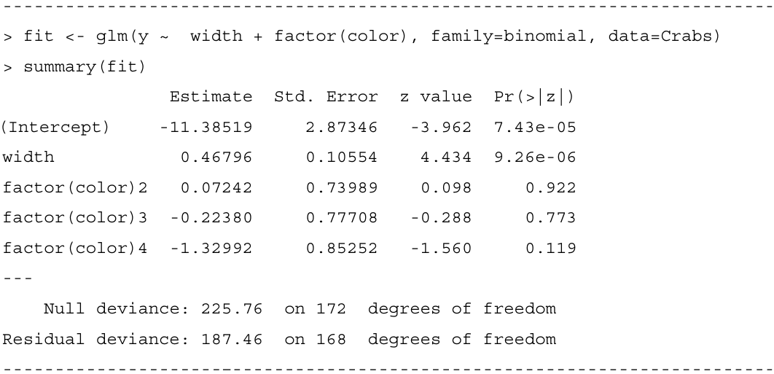
For medium-light colored crabs (category 1), $c_{2}=c_{3}=c_{4}=0$, and the prediction equation is
$$logit\left[\hat{P}\left(Y=1\right)\right]=-11.385+0.468x.$$
For dark crabs (category 4), $c_{2}=c_{3}=0$ and $c_{4}=1$, so the prediction equation is as below:
$$logit\left[\hat{P}\left(Y=1\right)\right]=\left(-11.385-1.330\right)+0.468x=-12.715+0.468x.$$
The exponentiated difference between two color parameter estimates is an odds ratio comparing those colors. For example, the difference in color parameter estimates between medium-light crabs and dark crabs equals 1.330. Therefore, at any fixed value of width, the estimated odds that a medium-light crab has a satellite are $\exp{(1.330)}=3.8$ times the estimated odds for a dark crab. Using the probabilities just calculated at width 26.3, the odds equal $0.399/0.601=0.66$ for a dark crab and $0.715/0.285=2.51$ for a medium-light crab, for which $2.51/0.66=3.8$.

4.4.2 Model comparison to check whether a term is needed.
To test whether color contributes significantly, we test $H_{0}:β_{2}=β_{3}=β_{4}=0$. This hypothesis states that, adjusting for width, the presence of at least one satellite is independent of color. The test statistic is
$$2\left(L_{1}-L_{0}\right)=194.45-187.46=6.99.$$
Under $H_{0}$, this test statistic has an approximate chi-squared distribution with $df=3$. The $P-value$ of 0.07 provides slight evidence of a color effect. Since the analysis in 4.4.1 noted that estimated probabilities are quite different for dark-colored crabs, it seems safest to leave color in the model.

4.4.3 Example: Treating color as quantitative or binary.
Color has a natural ordering of categories, from medium light to dark. A simpler model treats color in a quantitative manner. It is advantageous to treat ordinal explanatory variables in a quantitative manner, when such models fit well. The model is simpler and easier to interpret, and tests of the effect of the variable are generally more powerful when it has a single parameter rather than several parameters.
To illustrate, we use scores $c=(1,2,3,4)$ for the color categories and fit the model
$$logit\left[P\left(Y=1\right)\right]=α+β_{1}x+β_{2}c.$$
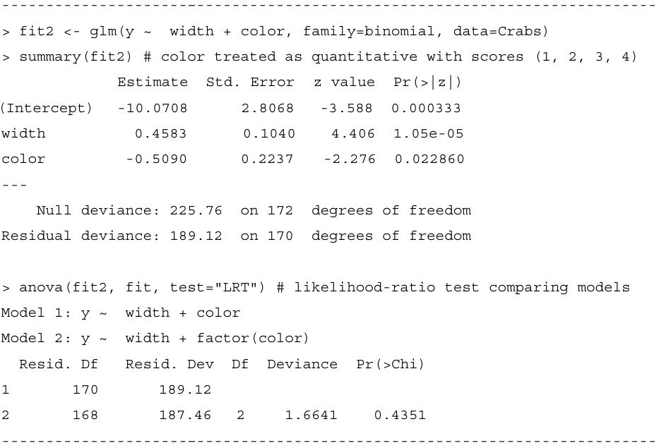
At a given width, for every one-category increase in color darkness, the estimated odds of a satellite multiply by $\exp{(-0.509)}=0.60$. For example, the estimated odds of a satellite for dark-colored crabs are 60% of those for medium-dark crabs. Since $\exp\left[3\left(-0.509\right)\right]=0.22$, the estimated odds of a satellite for dark-colored crabs are 22% of those for medium-light crabs.
The difference between the deviances equals $189.12-187.46=1.66$, with $df=2(P=0.44)$. It tests that the color parameters in model, when plotted against the color scores, follow a linear trend. The simpler model seems to be adequate.
The estimates of the color parameters in the model that treats color as a nominal scale factor are $(0, 0.07, -0.22, -1.33)$. The 0 value for the first category reflects the lack of an indicator variable for that category. Although these values do not depart significantly from a linear trend, the first three are similar compared to the last one. This suggests that another potential color scoring is $(0,0,0,1)$; that is, $c=1$ for dark-colored crabs, and $c=0$ otherwise.
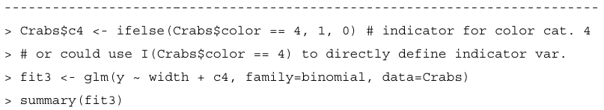
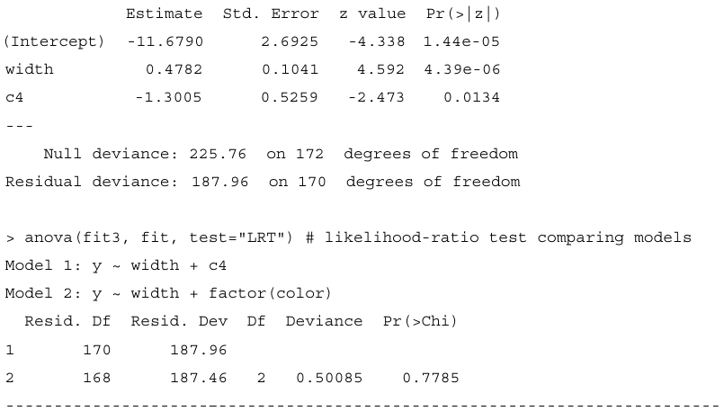
At a given width, the estimated odds that a dark crab has a satellite are $\exp\left(-1.3005\right)=0.27$ times the estimated odds for a lighter-colored crab. The likelihood-ratio statistic comparing this model with binary scoring to model (4.3) with color factor suggests that this simpler model also seems adequate.
In summary, the model with color factor, the model with quantitative color scores (1, 2,3,4), and the model with binary color scores (0,0,0,1) all suggest that dark crabs are the least likely to have satellites. When the sample size is not very large, typically several models can fit adequately.
4.4.4 Allowing Interaction between explanatory variables.
The models fitted so far assume a lack of interaction between width and color. Let us check now whether this is sensible. We can allow interaction by adding cross-products of terms for width and color. Each color then has a different-shaped curve relating width to the probability of a satellite, so a comparison of two colors varies according to the value of width.
To illustrate, we consider the model just fitted that has an indicator variable for dark-colored crabs. We next fit the model with an interaction term:
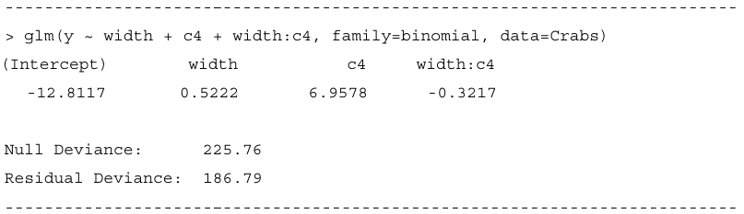
The prediction equation is
$$logit\left[\hat{P}\left(Y=1\right)\right]=-12.812+0.522x+6.958c_{4}-0.322\left(x∙c_{4}\right).$$
For dark-colored crabs $(c_{4}=1)$,
$$logit\left[\hat{P}\left(Y=1\right)\right]=-5.854+0.200x.$$
For lighter-colored crabs $\left(c_{4}=0\right)$,
$$logit\left[\hat{P}\left(Y=1\right)\right]=-12.812+0.522x.$$

